|  |  |
| --- | --- |
| **EXP NO:** **1** | **AZURE DEVOPS ENVIRONMENT SETUP** |

**Aim:**

To set up and access the Azure DevOps environment by creating an organization through the Azure portal.

**INSTALLATION**

1.Open your web browser and go to the Azure website: [https://azure.microsoft.com/en-us/getstarted/azure-portal.](https://azure.microsoft.com/en-us/get-started/azure-portal)

Sign in using your Microsoft account credentials.

If you don't have a Microsoft account, you can create one here: <https://signup.live.com/?lic=1>

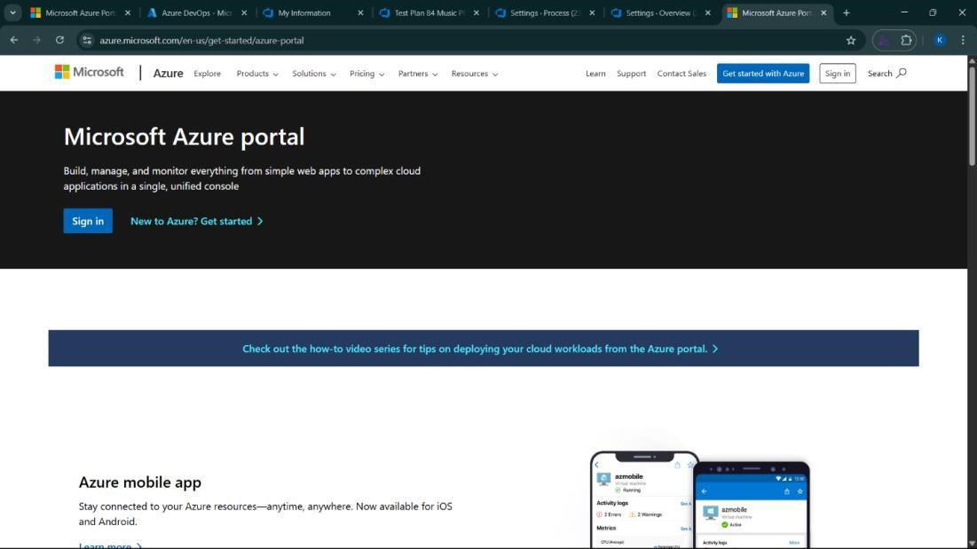

2.Azure home page

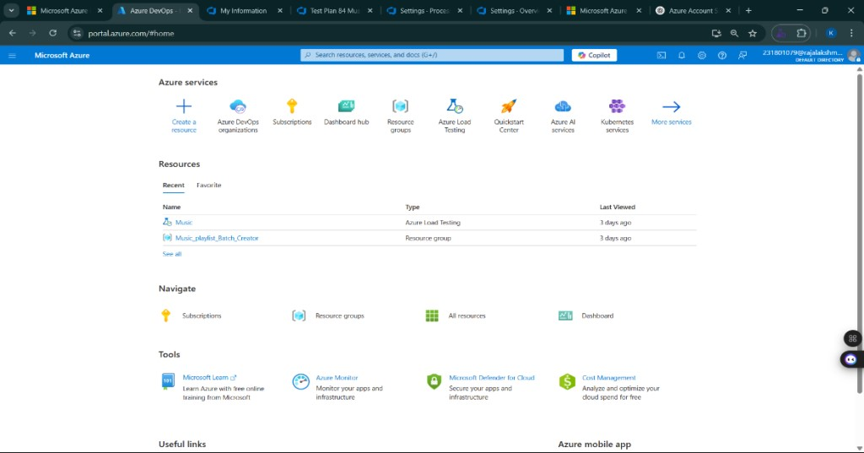

3.Open DevOps environment in the Azure platform by typing ***Azure DevOps Organizations*** in the search bar.

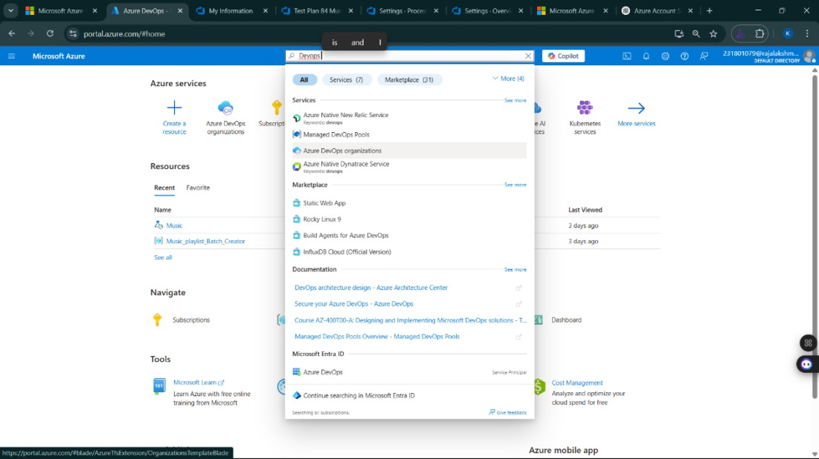

4.Click on the ***My Azure DevOps Organization*** link and create an organization and you should be taken to the Azure DevOps Organization Home page.

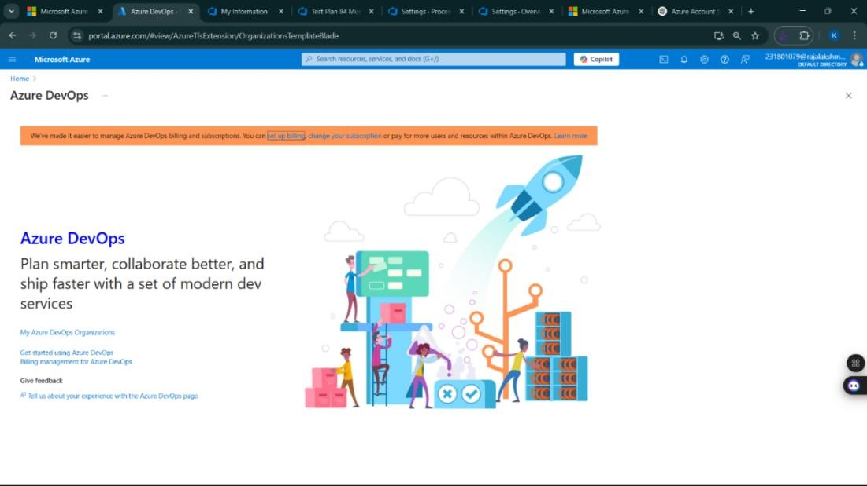

**Result:**

Successfully accessed the Azure DevOps environment and created a new organization through the Azure portal.

|  |  |
| --- | --- |
| **EXP NO:** **2** | **AZURE DEVOPS PROJECT SETUP AND USER STORY**  **MANAGEMENT** |

**Aim:**

To set up an Azure DevOps project for efficient collaboration and agile work management.

1.Create An Azure Account

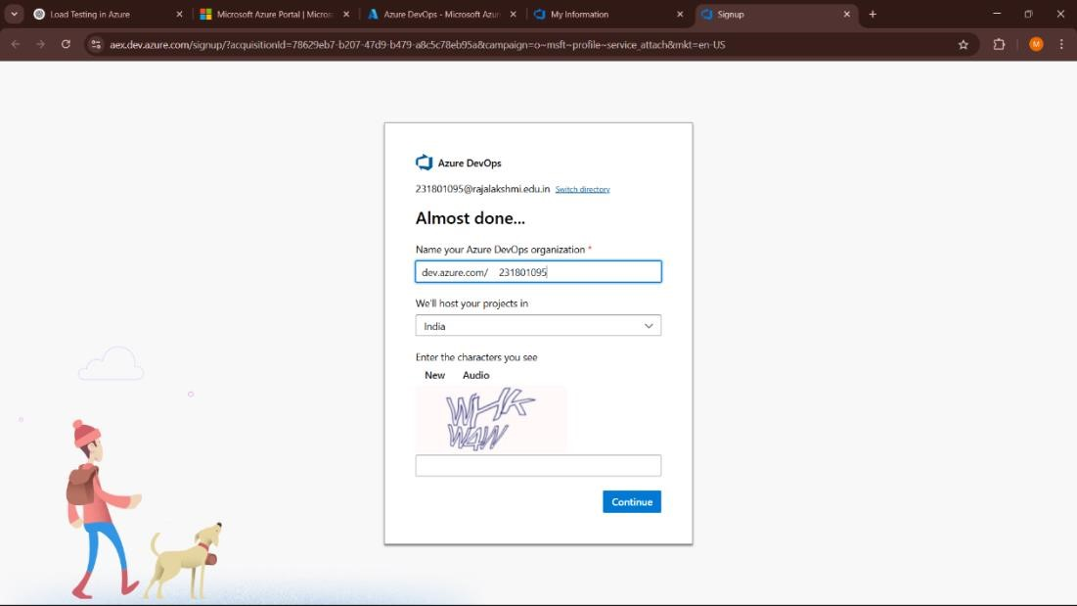

2.Create the First Project in Your Organization

1. After the organization is set up, you’ll need to create your first **project**. This is where you'll

begin to manage code, pipelines, work items, and more.

1. On the organization’s **Home page**, click on the **New Project** button.
2. Enter the project name, description, and visibility options:

***Name****:* Choose a name for the project (e.g., LMS).

***Description****:* Optionally, add a description to provide more context about the project. ***Visibility****:* Choose whether you want the project to be **Private** (accessible only to those invited) or **Public** (accessible to anyone).

1. Once you’ve filled out the details, click **Create** to set up your first project.

3.Once logged in, ensure you are in the correct organization. If you're part of multiple organizations, you can switch between them from the top left corner (next to your user profile). Click on the Organization name, and you should be taken to the Azure DevOps Organization Home page.

4.Project dashboard

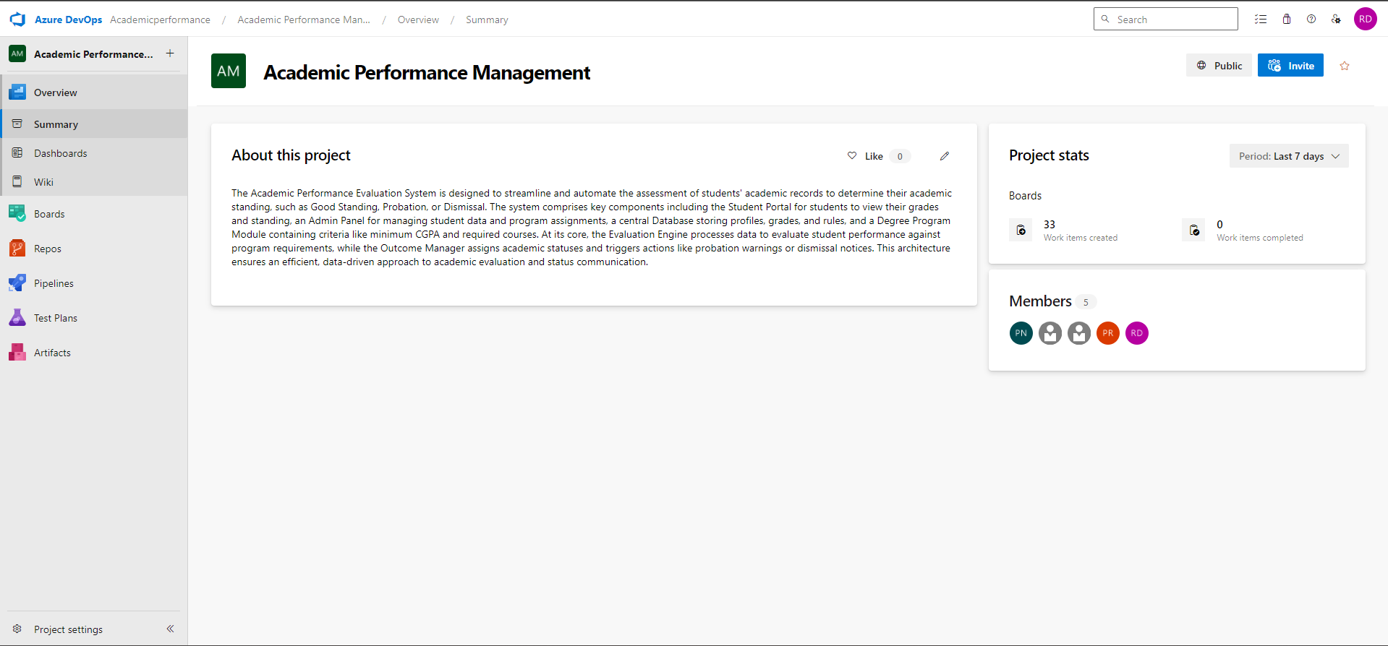

5.To manage user stories:

1. From the **left-hand navigation menu**, click on **Boards**. This will take you to the main **Boards**

page, where you can manage work items, backlogs, and sprints.

1. On the **work items** page, you'll see the option to **Add a work item** at the top. Alternatively,

you can find a **+** button or **Add New Work Item** depending on the view you're in. From the **Add a work item** dropdown, select **User Story**. This will open a form to enter details for the new User Story.

**Result:**

Successfully created an Azure DevOps project with user story management and agile workflow setup.

|  |  |
| --- | --- |
| **EXP NO:** **3** | **SETTING UP EPICS, FEATURES, AND USER STORIES**  **FOR PROJECT PLANNING** |

**Aim:**

To learn about how to create epics, user story, features, backlogs for your assigned project.

**Create Epic, Features, User Stories, Task**

# 1.Fill in Epics

# 2.Fill in Features

# 3.Fill in User Story Details

**Result:**

Thus, the creation of epics, features, user story and task has been created successfully.

|  |  |
| --- | --- |
| **EXP NO:** **4** | **SPRINT PLANNING** |

**Aim:**

To assign user story to specific sprint for the Music Playlist Batch Creator Project.

**Sprint Planning**

**Sprint 1**

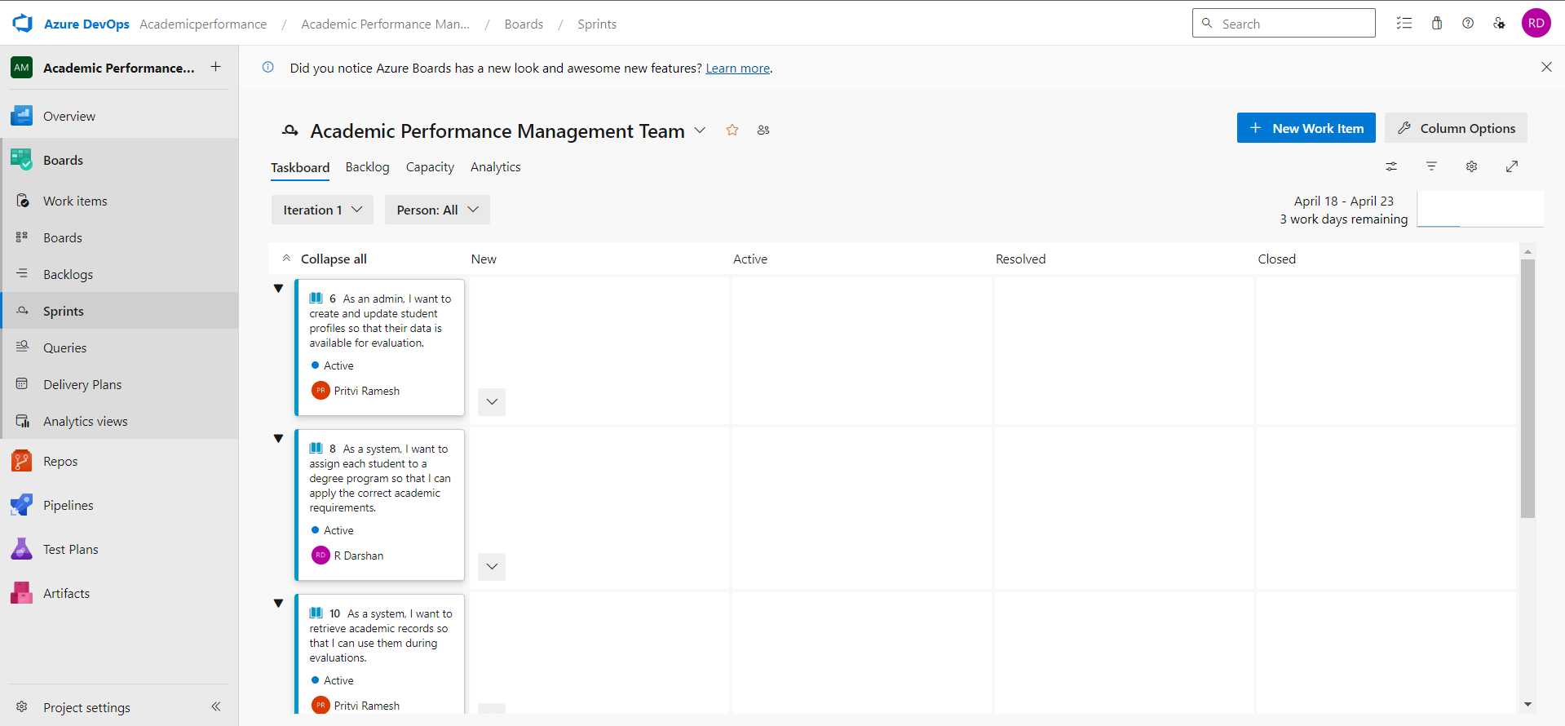

**Sprint 2**

**Sprint 3**

**Sprint 4**

**Result:**

The Sprints are created for Academic Performance Management.

|  |  |
| --- | --- |
| **EXP NO:** **5** | **POKER ESTIMATION** |

**Aim:**

Create Poker Estimation for the user stories - Academic Performance Management Project.

**Poker Estimation**

**Result:**

The Estimation/Story Points is created for the project using Poker Estimation.

|  |  |
| --- | --- |
| **EXP NO:** **6** | **DESIGNING CLASS AND SEQUENCE DIAGRAMS FOR**    **PROJECT ARCHITECTURE** |

**Aim:**

To Design a Class Diagram and Sequence Diagram for the given Project. **Class Diagram**

**6B. Sequence Diagram**

**Result:**

The Class Diagram and Sequence Diagram is designed Successfully for the Music Playlist Batch Creator.

|  |  |
| --- | --- |
| **EXP NO:** **7** | **DESIGNING ARCHITECTURAL AND ER DIAGRAM**    **FOR PROJECT STRUCTURE** |

**Aim:**

To Design an Architectural Diagram and ER Diagram for the given Project. **7A. Architectural Diagram**

**7B.ER Diagram**

**Result:**

The Architecture Diagram and ER Diagram is designed Successfully for the Academic Performance Management.

|  |  |
| --- | --- |
| **EXP NO:** **8** | **TESTING – TEST PLANS AND TEST CASES** |
|  |  |

**Aim:**

Test Plans and Test Case and write two test cases for at least five user stories showcasing the happy path and error scenarios in azure DevOps platform.

**Test Planning and Test Case**

**. Understand Core Features of the Application**

* **User Signup & Login**
* **Viewing and Managing Academic Records**
* **Generating Academic Reports**
* **Managing Course Information**
* **Generate Data Analytics and Insights**

**2. Define User Interactions**

* **Simulate real user behaviors: signing up, logging in, viewing records, generating reports, etc.**

**3. Design Happy Path Test Cases**

* **Focus on scenarios where everything works as expected (e.g., successful login, viewing records, generating reports).**

**4. Design Error Path Test Cases**

* **Simulate failure scenarios (e.g., invalid login, missing student info, failed report generation).**

**5. Break Down Steps and Expected Results**

* **For each test case, specify the actions and the expected outcome to ensure clarity for testers.**

**6. Use Clear Naming and IDs**

* **Name test cases clearly (e.g., TC01 – Successful Login, TC05 – Invalid Login).**

**7. Separate Test Suites**

* **Group test cases into different suites based on functionality: Signup/Login, Academic Records, Report Generation.**

**8. Prioritize and Review**

* **Prioritize critical user actions (e.g., login, managing records) and ensure all test cases are complete and traceable.**

**1.New test plan**

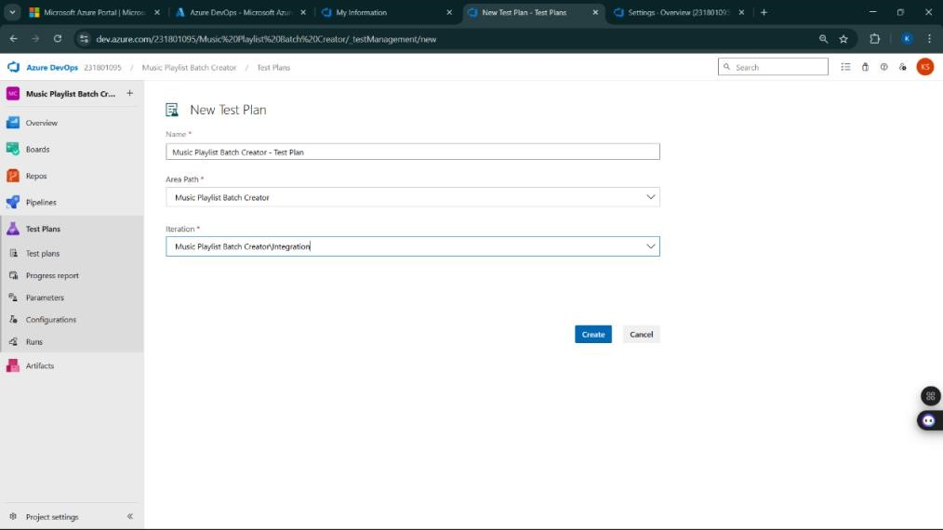

**2.Test suite**

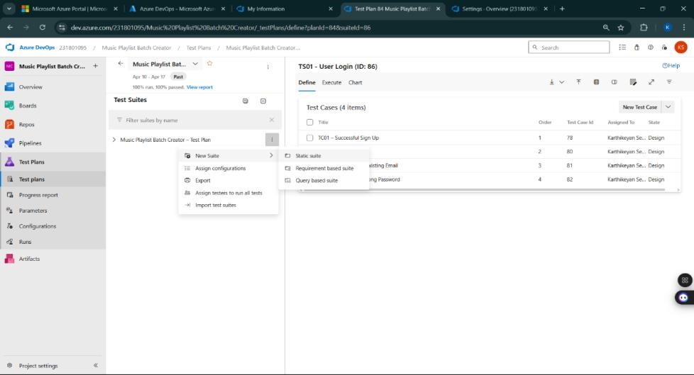

**Test Case Design Procedure for Academic Evaluator**

**USER STORIES:**

1. **As a user, I want to sign up and log in securely so that I can access my academic records.** (ID: 79)
2. **As a user, I need to view my academic records in one place.** (ID: 76)
3. **As a user, I should be able to create, update, and manage my academic records.** (ID: 73)
4. **As a user, I should be able to generate academic performance reports based on various criteria (e.g., semester, subject, grade).** (ID: 68)
5. **As a user, I need to have real-time access to my academic metadata and performance insights.** (ID: 65)

**Test Suites**

**Test Suit: TS01 - User Login and Signup (ID: 86)**

1. **TC01 – Successful Sign Up**
   * **Action:**
     + Go to the Sign-Up page.
     + Enter valid name, email, and password.
     + Click "Sign Up".
   * **Expected Results:**
     + Sign-Up form is displayed.
     + Fields accept values without error.
     + Account is created, and the user is redirected to the dashboard.
   * **Type:** Happy Path
2. **TC02 – Secure Login**
   * **Action:**
     + Go to the Login page.
     + Enter valid email and password.
     + Click on "Login".
   * **Expected Results:**
     + Login form is displayed.
     + Fields accept data without error.
     + User is logged in and redirected to the dashboard.
   * **Type:** Happy Path
3. **TC03 – Sign Up with Existing Email**
   * **Action:**
     + Go to the Sign-Up page.
     + Enter a name and an already registered email.
     + Click on "Sign Up".
   * **Expected Results:**
     + Fields accept data.
     + Error message "Email already registered" is displayed.
   * **Type:** Error Path
4. **TC04 – Login with Incorrect Password**
   * **Action:**
     + Go to the Login page.
     + Enter valid email and incorrect password.
     + Click on "Login".
   * **Expected Results:**
     + Error message "Invalid username or password" is shown.
   * **Type:** Error Path

**Test Suit: TS02 - View Academic Records (ID: 87)**

1. **TC05 – View Academic Records Successfully**
   * **Action:**
     + Log in successfully.
     + Navigate to "My Academic Records" section.
   * **Expected Results:**
     + All academic records are displayed clearly.
   * **Type:** Happy Path
2. **TC06 – Academic Records Loading Failure**
   * **Action:**
     + Disconnect from the internet.
     + Navigate to "My Academic Records".
   * **Expected Results:**
     + Network is offline.
     + Error message "Unable to load records" is shown.
   * **Type:** Error Path

**Test Suit: TS03 - Generate Academic Performance Reports (ID: 88)**

1. **TC07 – Generate Report Based on Filters**
   * **Action:**
     + Log in successfully.
     + Navigate to the "Generate Report" page.
     + Select filters (e.g., semester, subject, grades).
     + Click "Generate Report".
   * **Expected Results:**
     + Report is generated based on selected filters (semester, subject, grades).
   * **Type:** Happy Path
2. **TC08 – Report Generation Failure (Invalid Filter Selection)**
   * **Action:**
     + Log in successfully.
     + Navigate to the "Generate Report" page.
     + Select invalid or no filters.
     + Click "Generate Report".
   * **Expected Results:**
     + Error message "Please select valid filters" or "No data found for selected criteria".
   * **Type:** Error Path

**Test Suit: TS04 - Manage Academic Records (ID: 89)**

1. **TC09 – Update Academic Record Successfully**
   * **Action:**
     + Log in successfully.
     + Navigate to "My Academic Records".
     + Click "Edit" next to a record.
     + Update details (e.g., grades).
     + Click "Save".
   * **Expected Results:**
     + Record is updated and saved successfully.
   * **Type:** Happy Path
2. **TC10 – Update Record with Empty Fields**
   * **Action:**
     + Log in successfully.
     + Navigate to "My Academic Records".
     + Click "Edit" next to a record.
     + Leave fields empty or incorrect.
     + Click "Save".
   * **Expected Results:**
     + Error message "Field cannot be empty" or "Invalid data".
   * **Type:** Error Path

**Test Suit: TS05 - Real-Time Metadata Access (ID: 90)**

1. **TC11 – Real-Time Performance Insights**
   * **Action:**
     + Log in successfully.
     + View academic performance dashboard.
   * **Expected Results:**
     + Real-time metadata (e.g., GPA, semester performance) is displayed and updates in real-time.
   * **Type:** Happy Path
2. **TC12 – Metadata Not Updating**
   * **Action:**
     + Log in successfully.
     + View academic performance dashboard.
     + Do not receive updates or data remains static.
   * **Expected Results:**
     + Error message "Failed to fetch real-time data".
   * **Type:** Error Path

**Test Cases**

**4.Installation of test**

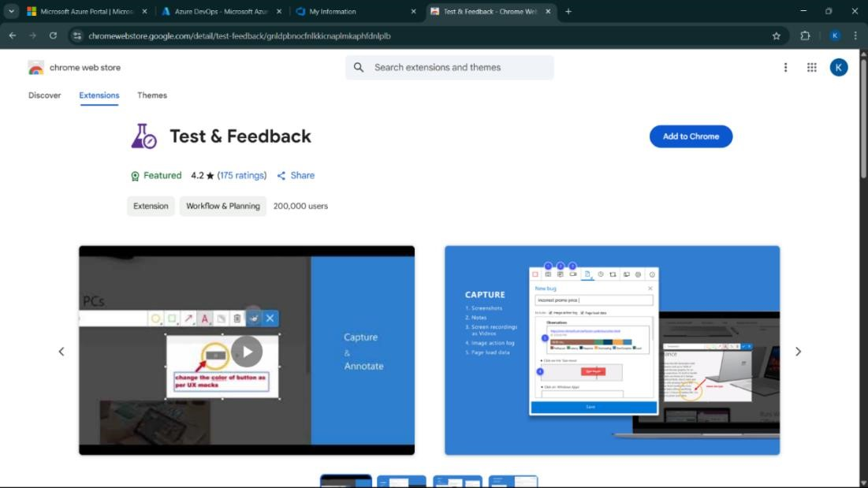

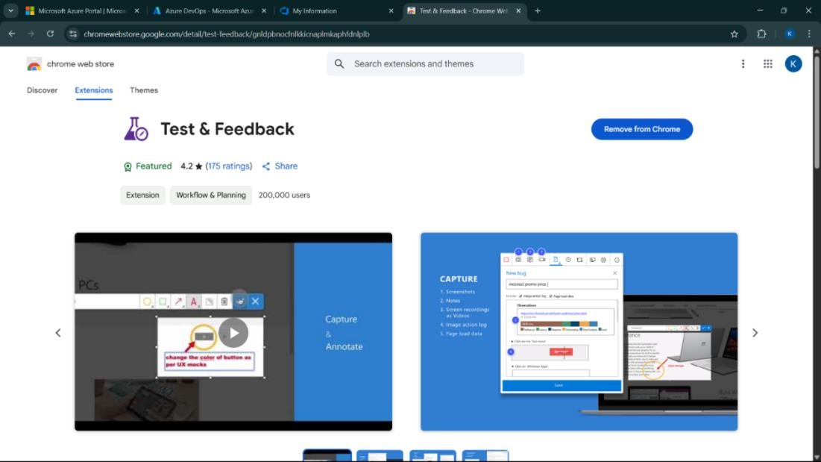

Test and feedback

Showing it as an extension

**5.Running the test cases**

x

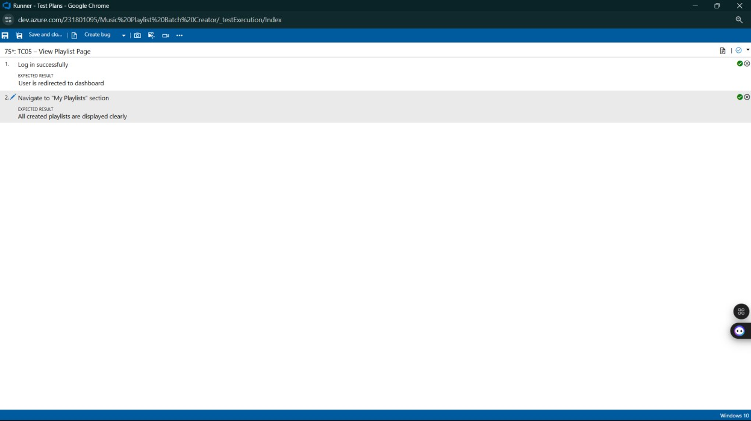

**6.Recording the test case**

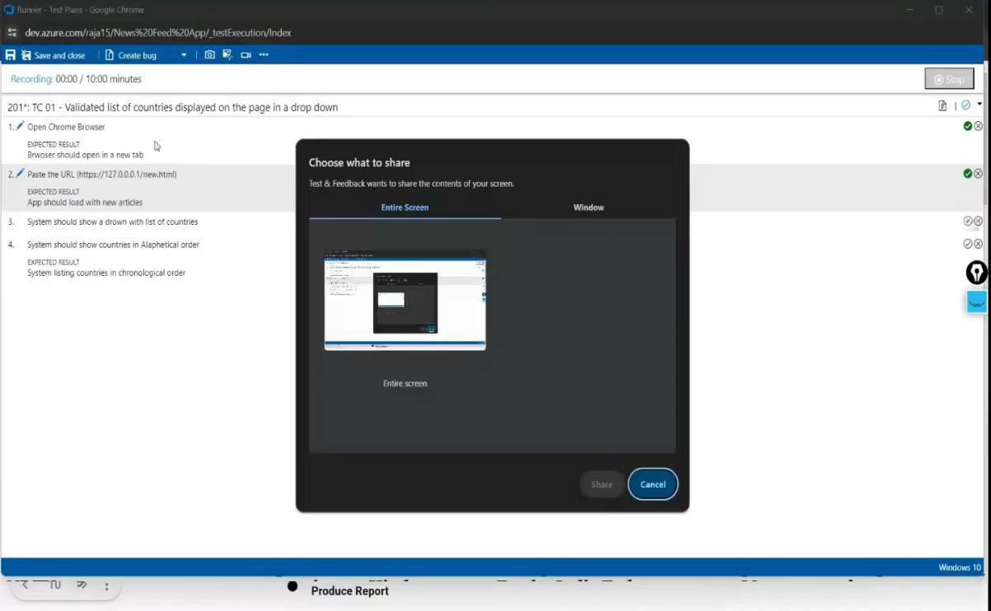

**7.Creating the bug**

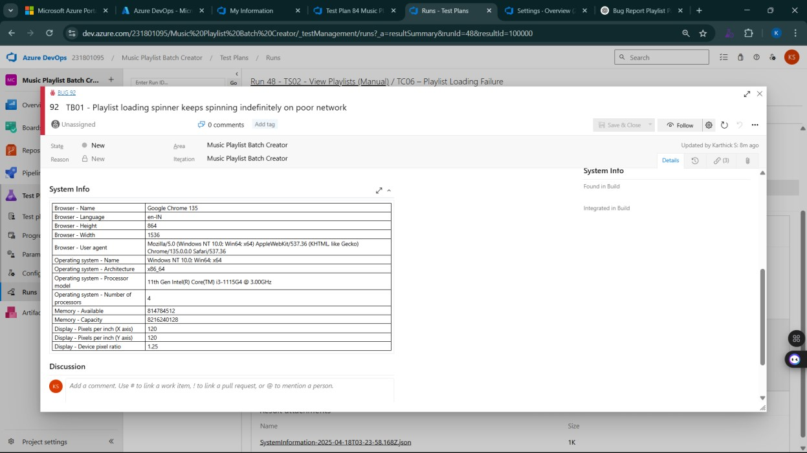

**8.Test case results**

**9.Test report summary**

• Assigning bug to the developer and changing state

**10.Progress report**

**11.Changing the test template**

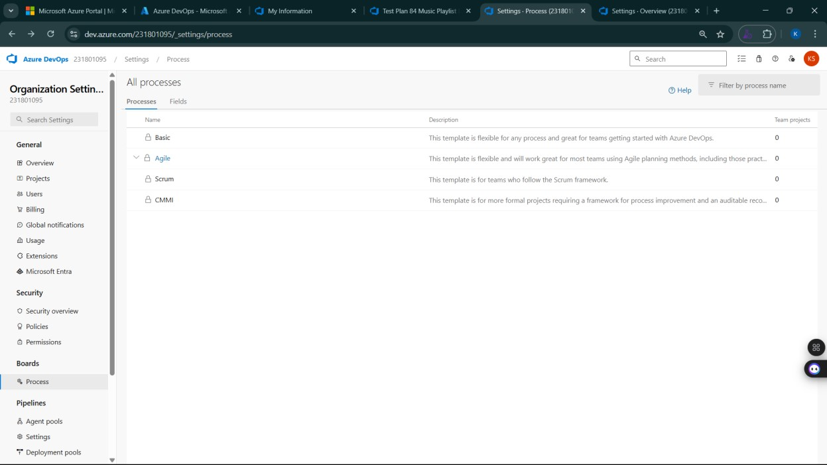

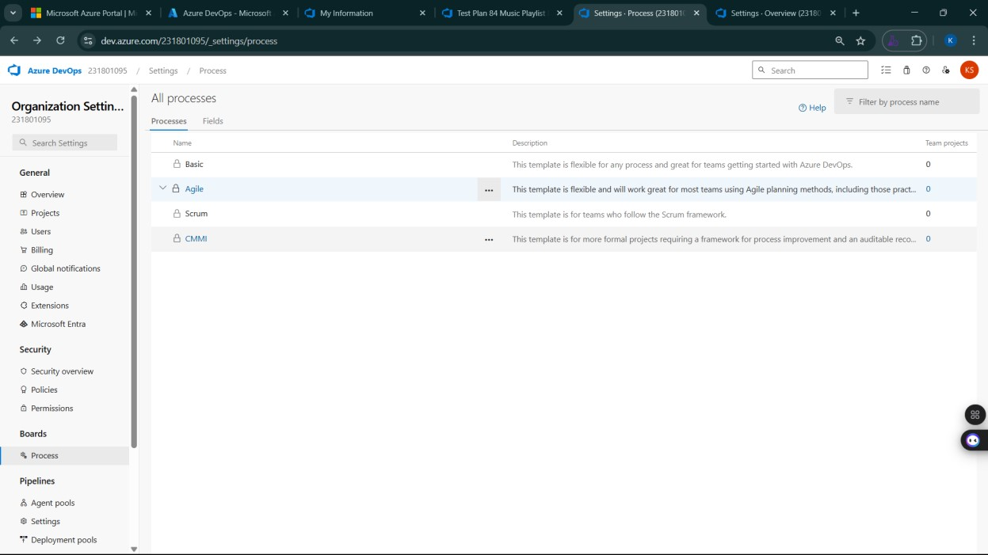

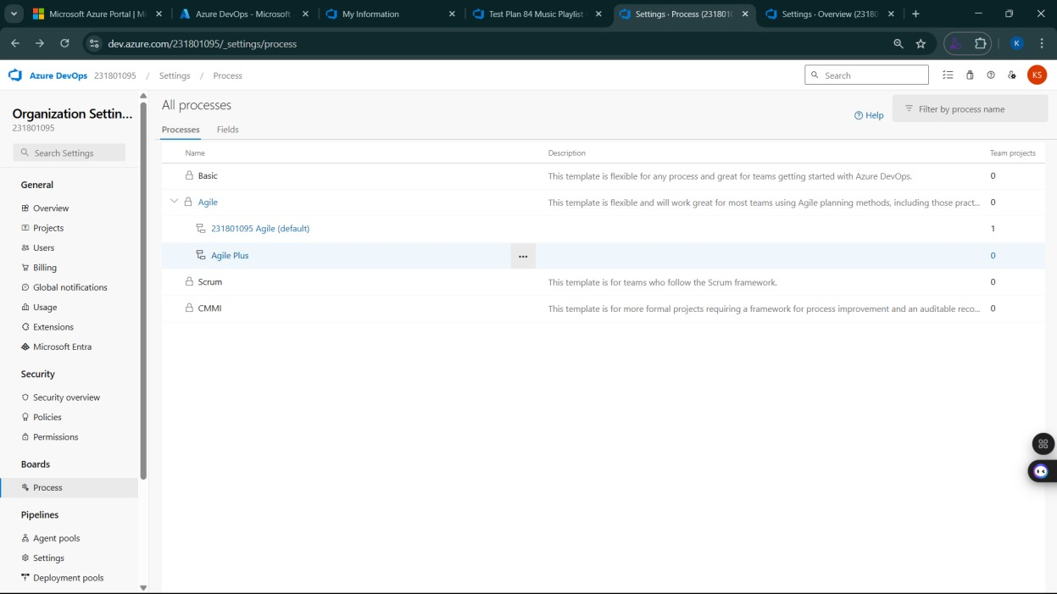

**12.View the new test case template**

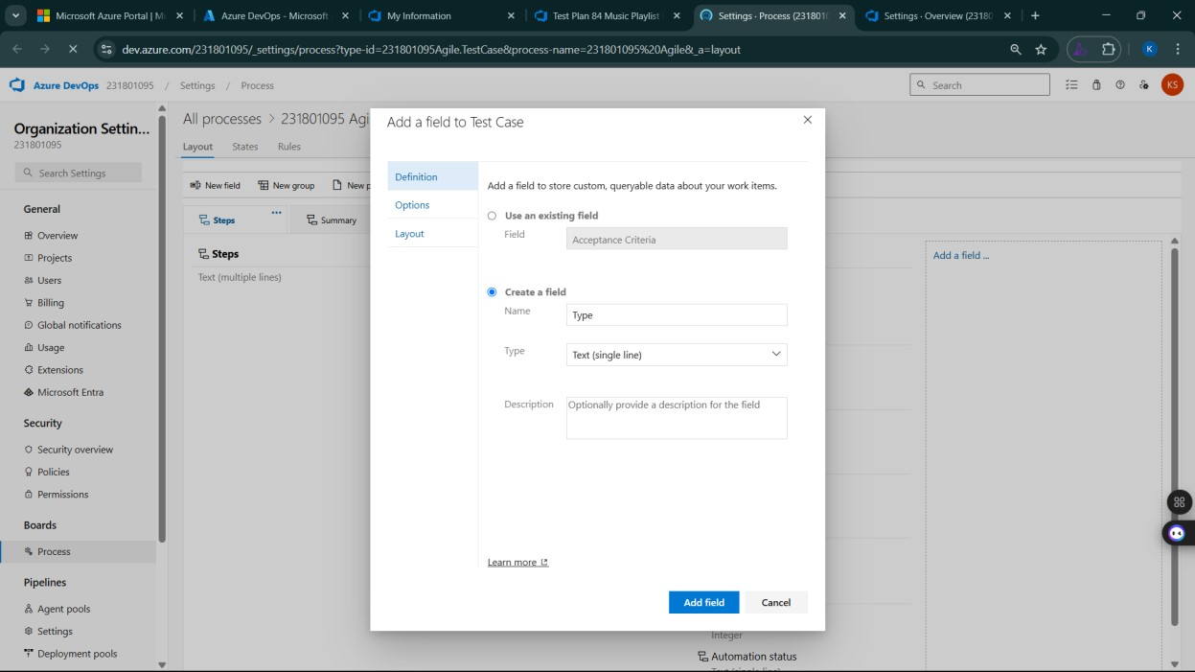

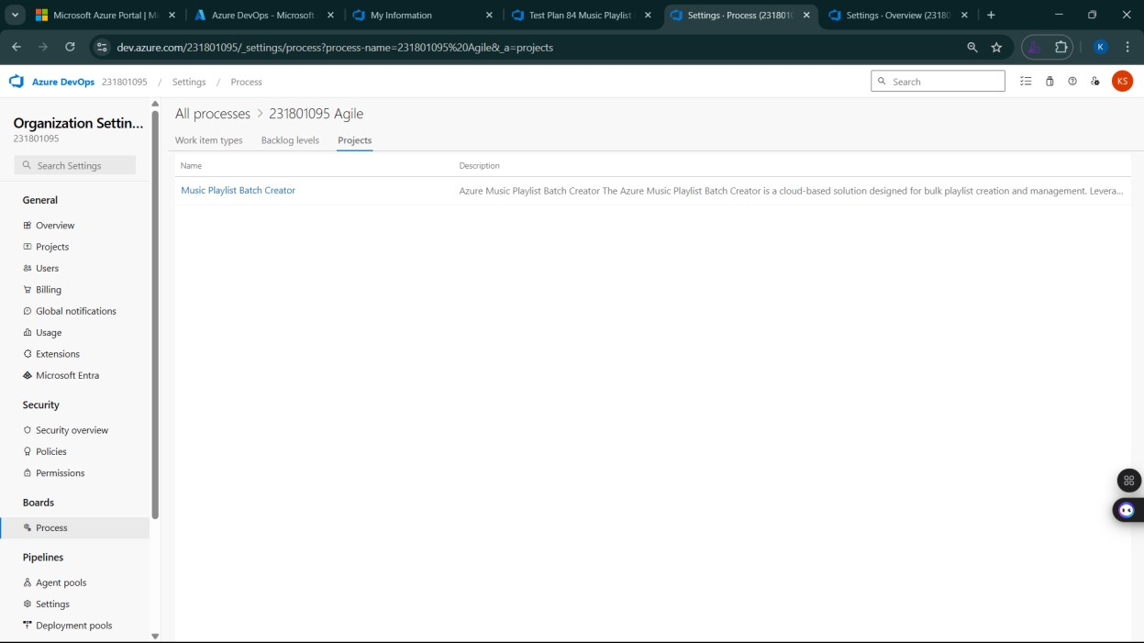

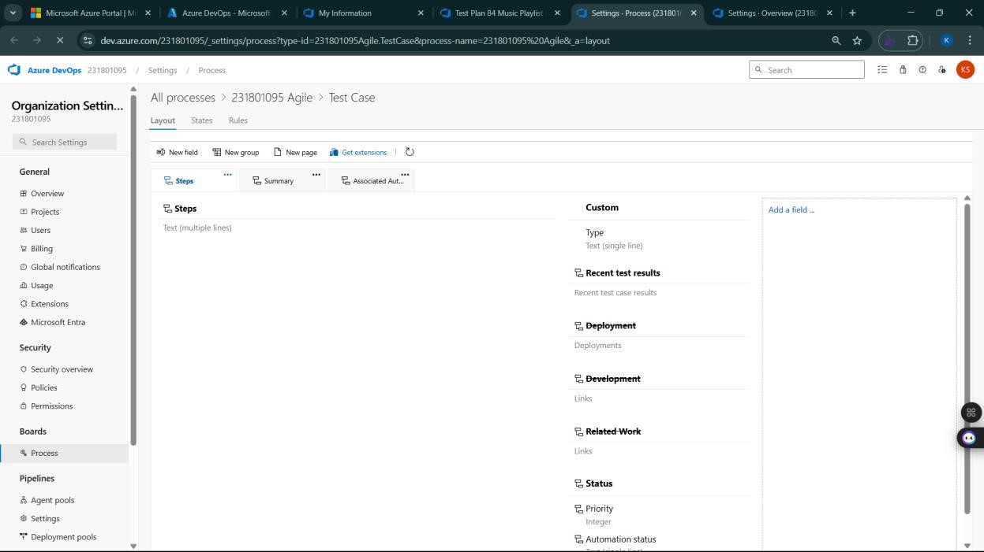

**Result:**

The test plans and test cases for the user stories is created in Azure DevOps with Happy Path and

Error Path

|  |  |
| --- | --- |
| **EXP NO:** **9** | **LOAD TESTING AND PERFORMANCE TESTING** |

**Aim:**

To create an Azure Load Testing resource and run a load test to evaluate the performance of a target endpoint.

**Load Testing**

**Steps to Create an Azure Load Testing Resource:**

Before you run your first test, you need to create the Azure Load Testing resource:

1. Sign in to Azure Portal

Go to [https://portal.azure.com](https://portal.azure.com/) and log in.

1. Create the Resource o Go to *Create a resource* → Search for “Azure Load Testing”.
   * Select Azure Load Testing and click Create.
2. Fill in the Configuration Details Subscriptio*n:* Choose your Azure subscription. o *Resource* *Group:* Create new or select an existing one. o *Name:* Provide a unique name (no special characters).
   * *Location:* Choose the region for hosting the resource.
3. (Optional) Configure tags for categorization and billing.
4. Click Review + Create, then Create.
5. Once deployment is complete, click Go to resource.

**Steps to Create and Run a Load Test:**

Once your resource is ready:

1. Go to your Azure Load Testing resource and click Add HTTP requests > Create.
2. Basics Tab o *Test Name:* Provide a unique name.
   * *Description:* (Optional) Add test purpose.
   * *Run After Creation:* Keep checked.
3. Load Settings o *Test URL:* Enter the target endpoint (e.g., https://yourapi.com/products).
4. Click Review + Create → Create to start the test.

**Load Testing**

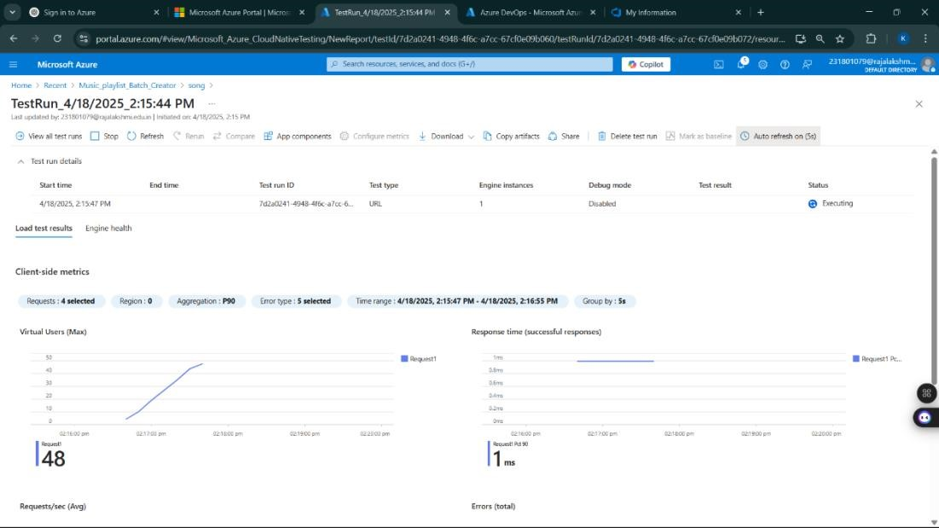

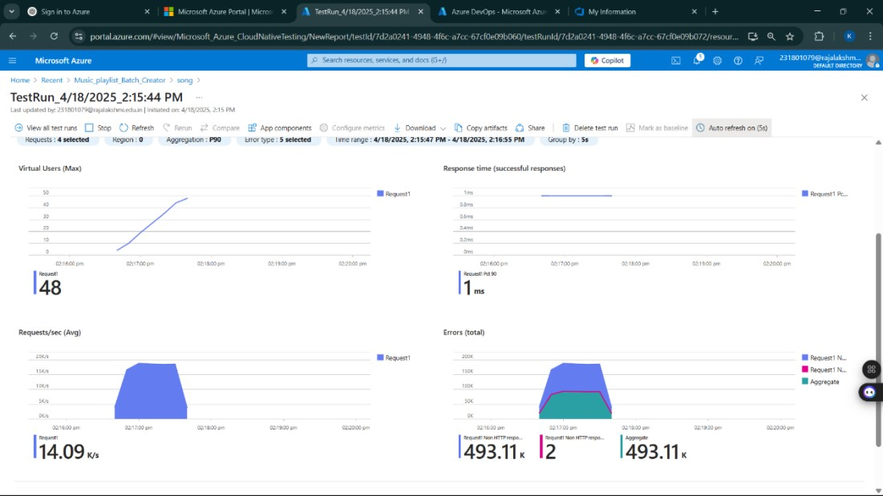

**Result:**

Successfully created the Azure Load Testing resource and executed a load test to assess the performance of the specified endpoint.

|  |  |
| --- | --- |
| **EXP NO:****10** | **GITHUB: PROJECT STRUCTURE & NAMING**  **CONVENTIONS** |

**Aim:**

To provide a clear and organized view of the project's folder structure and file naming conventions, helping contributors and users easily understand, navigate, and extend the Academic Performance project.

**GitHub Project Structure**

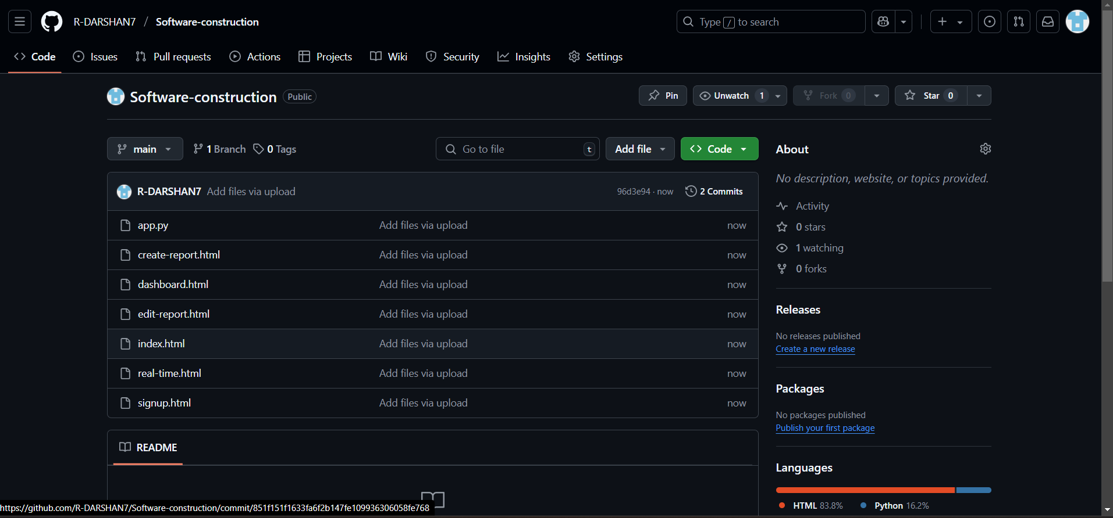

**Result:**

The GitHub repository clearly displays the organized project structure and consistent naming conventions, making it easy for users and contributors to understand and navigate the codebase.